**20CYS404**

Android Application Development

END SEM LAB

Nikhilesh M

21051

**Exp 1**

**Aim:**

To develop an Android Application to create a Course Registration Form, Name, Course and Fees,

and Storage should be done in SQLite and Firebase

**Code:**

**Activity.xml**

<?xml version="1.0" encoding="utf-8"?>  
<RelativeLayout xmlns:android="http://schemas.android.com/apk/res/android"  
 android:layout_width="match_parent"  
 android:layout_height="match_parent"  
 android:padding="16dp">  
  
 <!-- Title -->  
 <TextView  
 android:id="@+id/tvTitle"  
 android:layout_width="wrap_content"  
 android:layout_height="wrap_content"  
 android:text="Course Registration"  
 android:textSize="24sp"  
 android:textStyle="bold"  
 android:layout_centerHorizontal="true"  
 android:layout_marginTop="30dp"/>  
  
 <!-- Name and Roll Number TextView -->  
 <TextView  
 android:id="@+id/tvStudentInfo"  
 android:layout_width="wrap_content"  
 android:layout_height="wrap_content"  
 android:layout_alignParentEnd="true"  
 android:layout_marginTop="0.1dp"  
 android:text="Name: John Doe\nRoll No: 123456"  
 android:textSize="16sp"  
 android:textStyle="bold"  
 android:layout_marginStart="16dp"/>  
  
 <!-- Input Fields -->  
 <EditText  
 android:id="@+id/etId"  
 android:layout_width="match_parent"  
 android:layout_height="wrap_content"  
 android:hint="Enter ID"  
 android:layout_below="@+id/tvTitle"  
 android:layout_marginTop="20dp"  
 android:inputType="number"/>  
  
 <EditText  
 android:id="@+id/etName"  
 android:layout_width="match_parent"  
 android:layout_height="wrap_content"  
 android:hint="Enter Name"  
 android:layout_below="@+id/etId"  
 android:layout_marginTop="10dp"/>  
  
 <EditText  
 android:id="@+id/etCourse"  
 android:layout_width="match_parent"  
 android:layout_height="wrap_content"  
 android:hint="Enter Course"  
 android:layout_below="@+id/etName"  
 android:layout_marginTop="10dp"/>  
  
 <EditText  
 android:id="@+id/etFee"  
 android:layout_width="match_parent"  
 android:layout_height="wrap_content"  
 android:hint="Enter Fee"  
 android:inputType="number"  
 android:layout_below="@+id/etCourse"  
 android:layout_marginTop="10dp"/>  
  
 <!-- Buttons -->  
 <Button  
 android:id="@+id/btnOk"  
 android:layout_width="wrap_content"  
 android:layout_height="wrap_content"  
 android:text="OK"  
 android:layout_below="@+id/etFee"  
 android:layout_marginTop="20dp"  
 android:layout_alignParentStart="true"/>  
  
 <Button  
 android:id="@+id/btnView"  
 android:layout_width="wrap_content"  
 android:layout_height="wrap_content"  
 android:text="VIEW"  
 android:layout_below="@+id/etFee"  
 android:layout_marginTop="20dp"  
 android:layout_toEndOf="@id/btnOk"  
 android:layout_marginStart="16dp" />   
  
 <Button  
 android:id="@+id/btnEdit"  
 android:layout_width="wrap_content"  
 android:layout_height="wrap_content"  
 android:text="EDIT"  
 android:layout_below="@+id/etFee"  
 android:layout_marginTop="20dp"  
 android:layout_toEndOf="@id/btnView"  
 android:layout_marginStart="16dp"/>   
  
 <!-- ListView for Displaying Data -->  
 <ListView  
 android:id="@+id/listViewCourses"  
 android:layout_width="match_parent"  
 android:layout_height="wrap_content"  
 android:layout_marginTop="20dp"  
 android:visibility="gone"/>  
</RelativeLayout>

**MainActivity.java**  
package com.example.myapplication;  
  
import android.database.Cursor;  
import android.os.Bundle;  
import android.view.View;  
import android.widget.Button;  
import android.widget.EditText;  
import android.widget.ListView;  
import android.widget.SimpleCursorAdapter;  
import android.widget.Toast;  
  
import androidx.appcompat.app.AppCompatActivity;  
  
public class MainActivity extends AppCompatActivity {  
  
 EditText etName, etCourse, etFee;  
 Button btnOk, btnView;  
 ListView listViewCourses;  
 DBHelper dbHelper;  
  
 @Override  
 protected void onCreate(Bundle savedInstanceState) {  
 super.onCreate(savedInstanceState);  
 setContentView(R.layout.*activity_main*);  
  
 // Initialize views  
 etName = findViewById(R.id.*etName*);  
 etCourse = findViewById(R.id.*etCourse*);  
 etFee = findViewById(R.id.*etFee*);  
 btnOk = findViewById(R.id.*btnOk*);  
 btnView = findViewById(R.id.*btnView*);  
 listViewCourses = findViewById(R.id.*listViewCourses*);  
  
 // Initialize DBHelper  
 dbHelper = new DBHelper(this);  
  
 // Insert data into the database when OK button is clicked  
 btnOk.setOnClickListener(new View.OnClickListener() {  
 @Override  
 public void onClick(View v) {  
 String name = etName.getText().toString();  
 String course = etCourse.getText().toString();  
 String feeString = etFee.getText().toString();  
  
 if (!name.isEmpty() && !course.isEmpty() && !feeString.isEmpty()) {  
 int fee = Integer.*parseInt*(feeString);  
 dbHelper.insertCourse(name, course, fee);  
 clearFields();  
 } else {  
 Toast.*makeText*(MainActivity.this, "Please fill all fields", Toast.*LENGTH_SHORT*).show();  
 }  
 }  
 });  
  
 // Display data in a ListView when View button is clicked  
 btnView.setOnClickListener(new View.OnClickListener() {  
 @Override  
 public void onClick(View v) {  
 displayCourses();  
 }  
 });  
 }  
  
 // Method to clear the input fields after inserting  
 private void clearFields() {  
 etName.setText("");  
 etCourse.setText("");  
 etFee.setText("");  
 }  
  
 // Method to display courses in ListView  
 private void displayCourses() {  
 Cursor cursor = dbHelper.getAllData();  
 if (cursor.getCount() == 0) {  
 Toast.*makeText*(MainActivity.this, "No Data to Display", Toast.*LENGTH_SHORT*).show();  
 listViewCourses.setVisibility(View.*GONE*);  
 return;  
 }  
  
 listViewCourses.setVisibility(View.*VISIBLE*);  
  
 String[] from = new String[]{"Name", "Course", "Fee"};  
 int[] to = new int[]{R.id.*tvName*, R.id.*tvCourse*, R.id.*tvFee*};  
  
 SimpleCursorAdapter adapter = new SimpleCursorAdapter(  
 this, R.layout.*list_item*, cursor, from, to, 0);  
 listViewCourses.setAdapter(adapter);  
 }  
}

**Database:**

package com.example.myapplication;  
  
import android.content.ContentValues;  
import android.content.Context;  
import android.database.Cursor;  
import android.database.sqlite.SQLiteDatabase;  
import android.database.sqlite.SQLiteOpenHelper;  
import android.widget.Toast;  
  
public class DBHelper extends SQLiteOpenHelper {  
  
 private static final String *DATABASE_NAME* = "CourseRegistration.db";  
 private static final String *TABLE_NAME* = "courses";  
 private static final String *COL_ID* = "ID";  
 private static final String *COL_NAME* = "Name";  
 private static final String *COL_COURSE* = "Course";  
 private static final String *COL_FEE* = "Fee";  
 private Context context;  
  
 // Constructor  
 public DBHelper(Context context) {  
 super(context, *DATABASE_NAME*, null, 1);  
 this.context = context;  
 }  
  
 // Called when the database is created for the first time  
 @Override  
 public void onCreate(SQLiteDatabase db) {  
 // Create table query  
 String createTable = "CREATE TABLE " + *TABLE_NAME* + " (" +  
 *COL_ID* + " INTEGER PRIMARY KEY AUTOINCREMENT, " +  
 *COL_NAME* + " TEXT, " +  
 *COL_COURSE* + " TEXT, " +  
 *COL_FEE* + " INTEGER)";  
 db.execSQL(createTable);  
 }  
  
 // Called when the database needs to be upgraded  
 @Override  
 public void onUpgrade(SQLiteDatabase db, int oldVersion, int newVersion) {  
 db.execSQL("DROP TABLE IF EXISTS " + *TABLE_NAME*);  
 onCreate(db);  
 }  
  
 // Method to insert data into the database  
 public boolean insertCourse(String name, String course, int fee) {  
 SQLiteDatabase db = this.getWritableDatabase();  
 ContentValues contentValues = new ContentValues();  
 contentValues.put(*COL_NAME*, name);  
 contentValues.put(*COL_COURSE*, course);  
 contentValues.put(*COL_FEE*, fee);  
 long result = db.insert(*TABLE_NAME*, null, contentValues);  
  
 if (result == -1) {  
 Toast.*makeText*(context, "Failed to Add Record", Toast.*LENGTH_SHORT*).show();  
 return false;  
 } else {  
 Toast.*makeText*(context, "Record Added", Toast.*LENGTH_SHORT*).show();  
 return true;  
 }  
 }  
 public Cursor getAllData() {  
 SQLiteDatabase db = this.getReadableDatabase();  
 return db.rawQuery("SELECT * FROM " + *TABLE_NAME*, null);  
 }  
 public boolean updateCourse(int id, String name, String course, int fee) {  
 SQLiteDatabase db = this.getWritableDatabase();  
 ContentValues contentValues = new ContentValues();  
 contentValues.put(*COL_NAME*, name);  
 contentValues.put(*COL_COURSE*, course);  
 contentValues.put(*COL_FEE*, fee);  
 int result = db.update(*TABLE_NAME*, contentValues, *COL_ID* + " = ?", new String[]{String.*valueOf*(id)});  
  
 if (result > 0) {  
 Toast.*makeText*(context, "Record Updated", Toast.*LENGTH_SHORT*).show();  
 return true;  
 } else {  
 Toast.*makeText*(context, "Failed to Update Record", Toast.*LENGTH_SHORT*).show();  
 return false;  
 }  
 }  
  
 public boolean deleteCourse(int id) {  
 SQLiteDatabase db = this.getWritableDatabase();  
 int result = db.delete(*TABLE_NAME*, *COL_ID* + " = ?", new String[]{String.*valueOf*(id)});  
  
 if (result > 0) {  
 Toast.*makeText*(context, "Record Deleted", Toast.*LENGTH_SHORT*).show();  
 return true;  
 } else {  
 Toast.*makeText*(context, "Failed to Delete Record", Toast.*LENGTH_SHORT*).show();  
 return false;  
 }  
 }  
}

**Screenshots:**

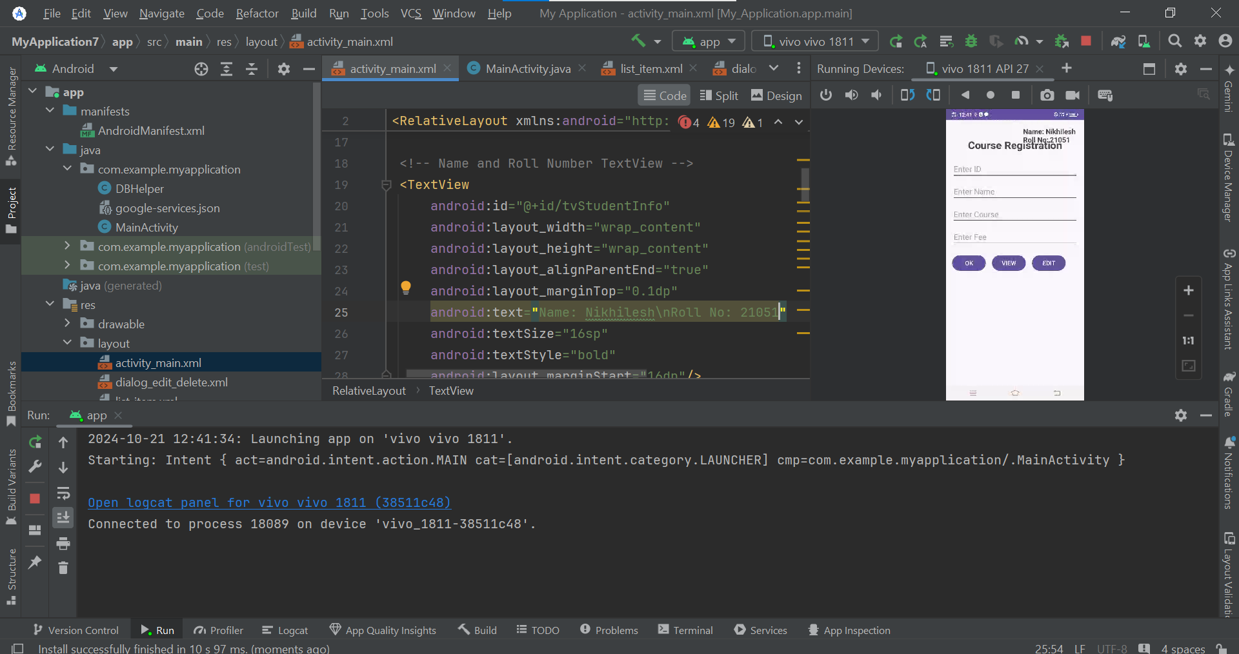

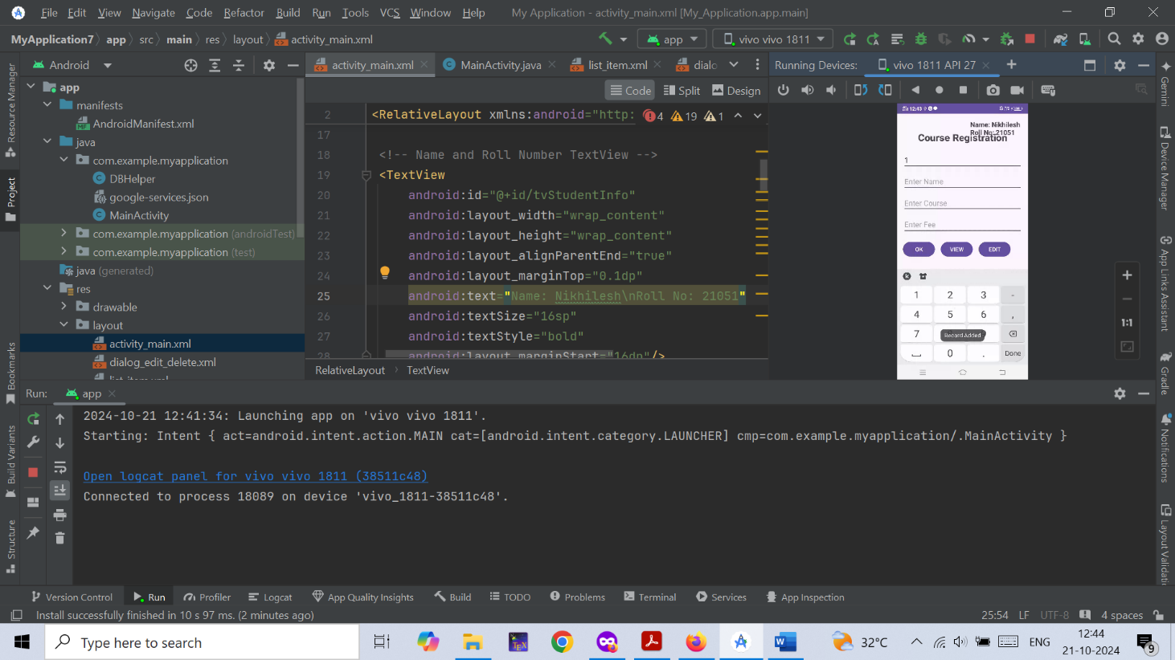

**Result:**

This is the required Application.